ASSIGNMENT-6



Red signifies stop on traffic signals, so this specification unified

red as a stop signal whether indicated by sign or by light.

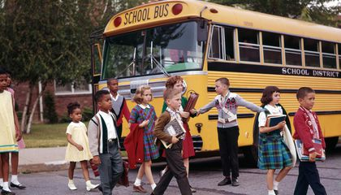

Even if a person is not looking straight, he can spot the yellow coloured school bus in front of him. That's why the school bus is painted yellow to lessen the possibility of an accident for the bus filled with children on the highway.

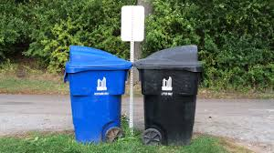

Blue recycling bins sometimes indicate a recycling bin used for metals. Although it is common to use blue bins to indicate recycling for metals, plastics also are often recycled using blue bins.

Typical items that might go in your black bin: Disposable nappies. Carrier or plastic bags. Plastic food wrapping (plastic that can be scrunched in your hand) e.g. salad bags, bread bag

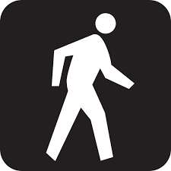

Pedestrian signals help pedestrians cross at intersections with traffic lights. The signal for pedestrians to walk is a white walking symbol. A flashing or steady orange hand symbol means pedestrians must not begin to cross. A pedestrian facing a walk signal may cross the road in the direction of the signal.

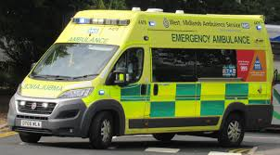

The term ambulance comes from the Latin word "ambulare" as meaning "to walk or move about" which is a reference to early medical care where patients were moved by lifting or wheeling. ... During the American Civil War vehicles for conveying the wounded off the field of battle were called ambulance wagons.